# Revenue Potential in Amazon UK Final Report Introduction

The project was requested by a retail owner who is experiencing financial pressure due to decline in sales. This project is aimed to investigate the success rate of Amazon FBA program for potential chance for the retail to establish an online shop to regain their customer base. Although this project was tasked specifically by a retailer, this study can be beneficial for any opportunist who seeks to explore Amazon FBA as an additional investment source.

This study is currently set to aid an “Art Supply” retailer, therefore the product listings only pertain to art. However, customization is possible to incorporate various other product categories.

The method used in this report is broken down into “revenue ranges” to provide a realistic snapshot of the possibilities offered by Amazon FBA. It is imperative to know that this study has its limitations and its insights are an approximation.

The analysis does not include Amazon FBA fees for storage, packaging, shipping & handling or customer returns. If all variables are put into consideration, one can expect that the revenue potential may be significantly lower.

# Business Impact

Exploring this data could inform retailers and opportunists of the potential risk and reward associated with Amazon FBA program. By examining past and existing Amazon listings, this study can provide an approximate earning potential as well as success and failure rates in a specific product category.

# Data

File Name: amz_uk_processed_data.csv

Description: Amazon UK Products Dataset 2023

Dataset Details: 1,680,129 Rows & 10 Columns

Size: 635,804KB ( 620MB )

Source: Kaggle - [Dataset Link](https://www.kaggle.com/datasets/asaniczka/amazon-uk-products-dataset-2023)

# Data Analysis & Computation

## Data Cleaning

* Import Dataset to DBeaver SQLite Database
* Examine dataset through SQL
* Using SQL WHERE CLAUSE, sorted attributes by field types. Some attributes contain text string fields when it should be numerical. 10 Records were filtered and repackaged into a CTE.
* Query essential data associated with problem statements
* Export data into Excel

## Analysis Methods

Analysis conducted and used for the datafolio.

* Analysis #1 - Total Records & Average Unit Price  
  To provide a general idea of the dataset as a whole.

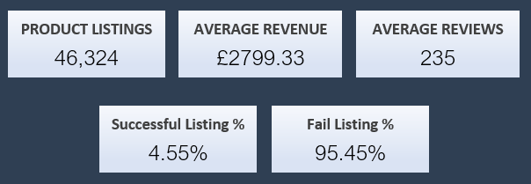

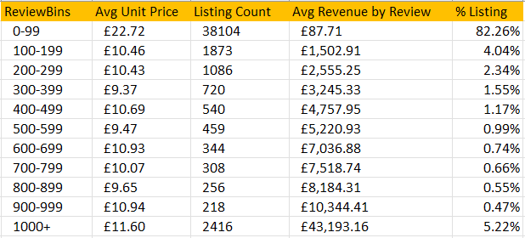

* Analysis #2 - Review Distribution  
  New table is tabulated by grouping Reviews into buckets to gauge revenue potential by the number of reviews a listing receives. This will provide a clearer picture of the marketing effort required to reach a specific revenue target. It also reveals the large disproportionate listing with extremely low revenues.
* Analysis #3 - **Basic Statistics**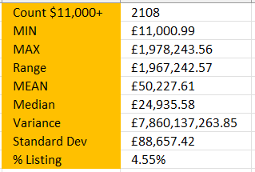

Upon learning about revenue potential by reviews. We would like to learn about how dispersed the listings are between success and failure. Central Tendency and Measure of Dispersion is used to show the skewness of the revenues between listings.

* Analysis #4 - **Revenue Distribution**

The review distribution might’ve revealed what a successful listing might look like, but it is not an accurate indicator of success. The statistics for listings with revenues of £11,000 contain a high level of dispersion. To further expand on the analysis. Revenue distribution table is created to show how many listings fall within a particular revenue range.

The distribution chart clearly shows why there is such a high Standard Deviation, primarily because there are too many listings that generated no revenues.

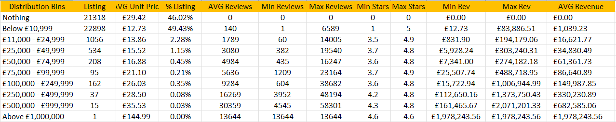

# Dashboard

The Dashboard’s ( [Link](https://public.tableau.com/app/profile/frankie.law3674/viz/AmazonFBAinUK/DropdownMenu) ) intended purpose is to provide an interactive filtering system to allow readers to further explore earning potential provided by Amazon FBA program. The dashboard breaks down the dataset by revenue range to inform the reader the success ratio and the necessary marketing effort to reach the target revenue.

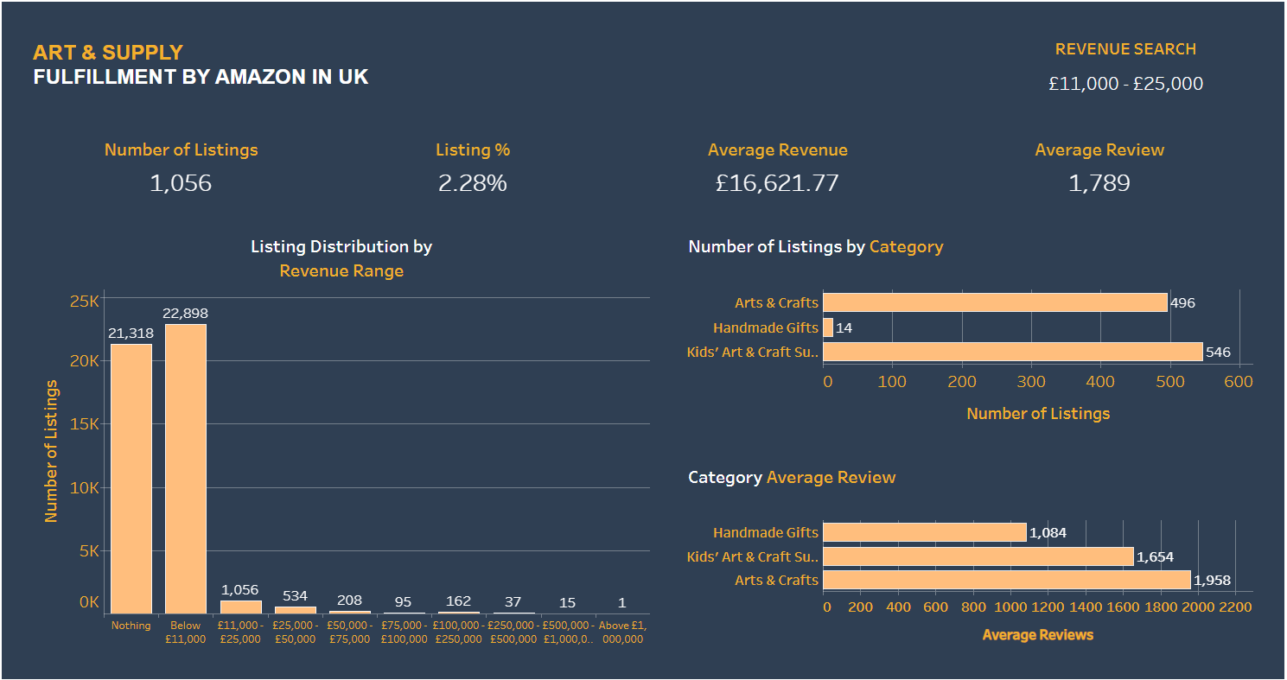

# Challenges

The dataset used can only determine revenues by confirming purchases left by reviewers. The study does not contain precise transactions that happened to each listing, therefore, all revenues are an approximation.

In addition, we are not able to gather information specifically about Amazon FBA to further understand the terms and conditions between Amazon and Vendor. It is expected that there will be hidden costs associated with this opportunity.

# Conclusion

Out of the 46,324 records across 4 categories. There is a disproportionate success to failure ratio with 46.02% of listings with no revenue recorded, and 49.43% of listings making less than £11,000. As with all businesses, a high failure rate is expected.

To achieve reasonable success on Amazon FBA, collectively there is 4.55% of listings making above £11,000. Note, this analysis assumed that the retail only has one listing. Having multiple products could potentially increase the chances of exposure that leads to successful sales.

However, the revenue shown is only an approximation from reality. Factors such as storage, packaging, shipping & handling or customer returns are not included in the calculation. Expect that the overall revenue can be much lower.

# Future Works

This study only analyzes the financial aspect of the business and it does not expand into online marketing analysis. This dataset can be used alongside a strong marketing team to devise strategy to attract potential buyers.

Further expansion of the analysis can be conducted by acquiring information from successful entrepreneurs to further understand the working mechanism of Amazon FBA program.